Applications Installed

Action | Options / Customisations
Installed IIS | All default options.
Installed FTP | All default options.
Configured IIS | Moved log files to E:\Logs\IIS.
Configured FTP | Moved log files to E:\Logs\FTP.
Installed SQL Server | Default options apart from:  Licensing ( 2 CPU )  Running under System Account  Application directory:  E:\Program Files\Microsoft SQL Server\MSSQL  Data Directory:  E:\Program Files\Microsoft SQL Server\MSSQL\Data
Install SQL Server SP3a | All default options.
Added DNS entries | Saltv3.bdw.com  Diagnostics.SaltV3.bdw.com

Passwords

Macquarie Corporate intellicentre Dedicated Server Hand Over for
BDW Technology Pty Ltd

CONTENTS

- Executive Summary

2 Summary of Service

3 Network Diagram

4 Security Descriptions

5 Back-up Options

6 Photo

7 User Guide

8 Help Desk

9 Responsibilities

10 Authorised Contacts

Prepared by:
Mirek Beltowski
Macquarie Corporate Telecommunications
www.mct.com.au
Phone: (02) 8204 5113
Fax: (02) 8204 5189

1. Executive Summary
Attention: | Claude Nehme | Email: | claude.nehme@bdw.com
From: | intellicentre Provisioning | Phone: | 9258 5748

CUSTOMER NAME: | BDW Technology Pty Ltd
PROJECT NUMBER: | P07108
SERVICE TYPE: | intellicentre Dedicated Server
SERVICE LEVEL CLASS | Business

I am delighted to confirm that the services listed below have now been completed and are in use. Please note that the billing of these services will commence on the Completion dates listed.

PRODUCT | DESCRIPTION |  | Install Fee | Monthly Charge | Completion Date
MIIDS21332001 | intellicentre  Intel Dedicated Server |  | - | $1725.00 | 05/09/2004
MIIDT21332001 | intellicentre  Internet Port |  | - | $200.00 | 05/09/2004
Monthly Data Transfer 2GB Ratio 5:1 Inbound & outbound. Excess inbound data $0.11 per MB. Excess Outbound data $0.11 per MB.

MITBUx21332001 |  | intellicentre  Tape Backup | - | $150.00 | 05/09/2004

NOTE: It is the customer’s responsibility to cancel any existing services with a previous supplier that are now replaced by services from Macquarie Corporate Telecommunications. When in doubt, please discuss with your Macquarie Corporate Telecommunications Account Manager.

- Summary of Service

Option | Type
Name | Bdw00001
Server Platform | HP GL360 G3
CPU | Zeon 3.2Ghz x 2
Hard Disk | 2 x 36 RAID 1
NIC | NIC 1 203.110.152.56  NIC 2 172.28.10.193
RAM | 2GB
Power Supply | Dual
Backup | Full Backup 1 x week  Incremental 6 x week
Access Capacity | Fixed 2 Mbps  Bursting 4 Mbps
Server Location | Level 16 Row C 1
user name and password | admin@bdwtech

To obtain your password, please contact the intellicentre Network Operations Centre (NOC) on 1800789999 Option 2, Option 1.
You will be prompted for your challenge and response password, which is PASSWORD.
Currently you are the only person authorised. Should you wish to add other people to the authorisation list, please fax the intellicentre NOC the names and contact details (including mobile, email and fax) of authorised contacts to fax 0282045189.
The challenge and response password will be the same for these people as above, unless specified on the fax.

3. Network Diagram

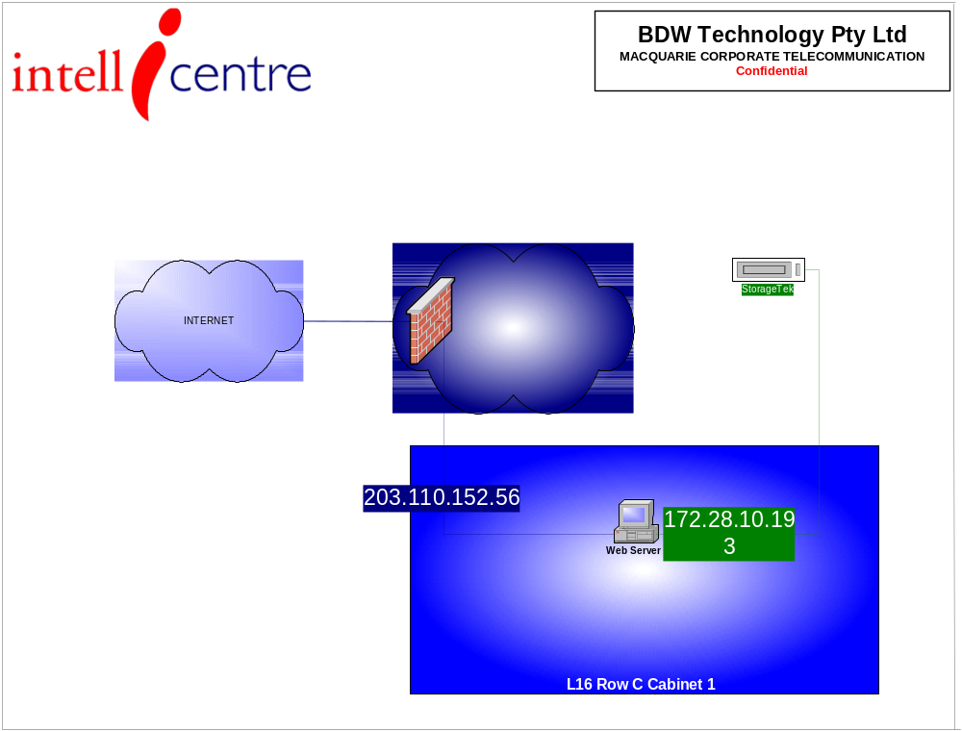

4. Security Description
All ports are disabled. Please complete Firewall Update Form.

You will not have connectivity to you server until you complete the Firewall Change Request form and fax to 0282045189.

Note: Should your require to add or remove Firewall Policies, please complete and fax a signed copy of the ‘Firewall Update Form’ attached. Note: during implementation you have two free modifications, further changes are charged at $62.50 (ex GST).

Firewall Change Request Form Attn: intellicentre NOC Fax: (02) 8204 5189
Company Name ________________
Contact Name ________________
Telephone ________________
Date ________________
Signature ________________

Protocol | Ports | Direction |  | Source IP |  | Destination IP
Protocol | Ports | In | Out |  |  | Destination IP
HTTP | 80 tcp |  |  | All or/ |  | All or/
FTP | 21 tcp |  |  | All or/ |  | All or/
SMTP | 25 tcp |  |  | All or/ |  | All or/
ICMP |  |  |  | All or/ |  | All or/
HTTPS | 443 tcp |  |  | All or/ |  | All or/
Terminal Services | 3389 tcp |  |  | All or/ |  | All or/
DNS | 53 tcp 53 udp |  |  | All or/ |  | All or/
SSH | 22 tcp |  |  | All or/ |  | All or/

Custom Services
Please provide
Supply
details below
- | - |  |  | All or/ | All or/
- | - |  |  | All or/ | All or/
- | - |  |  | All or/ | All or/
- | - |  |  | All or/ | All or/
- | - |  |  | All or/ | All or/
- | - |  |  | All or/ | All or/

5. Backup

The intellicentre provides a backup of your dedicated server using Veritas Backup Software.

Please be aware that the software can not backup ‘open files’ such as SQL or Exchange.

If you have these types of services running on your Dedicate Server, please ensure that you have a process in place which will ‘dump’ the data to a ‘flat file system’ which the Veritas Agent can successfully backup.

The intellicentre provides an automated backup report every day which is delivered via email. Please contact the intellicentre NOC to specify email address you wish the report to be sent to.

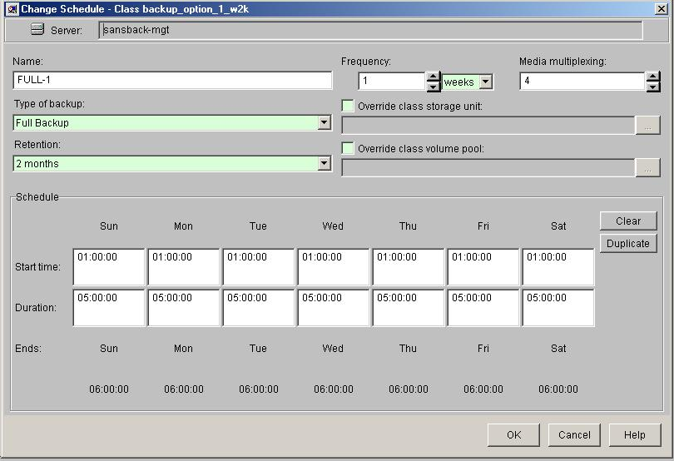

- Photo

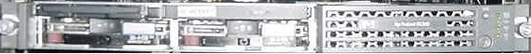

- User Guide

Introduction
Welcome, and thank you for choosing Macquarie Corporate Telecommunications as your Internet Hosting partner.

This documents is be used as an introductory guide to administering your Windows 2000 Dedicated Server from your local machine.
Outlined within this guide are the following topics:

- Installed Windows Components and Services
- Remotely connecting to your Windows 2000 Dedicated Server via Microsoft Remote Desktop Connection.
- Remotely transferring files to and from your Windows 2000 Dedicated Server through the use of Web Folders.
- Configuring Storage Devices via Computer Management Snap-In

Assumptions:

- The local machine you are using to connect to your Windows 2000 Dedicated Server is running Windows 2000 Professional, Server, or or above.
- You have remote desktop connection application installed on your local machine.
- The local machine you are using to connect to your Windows 2000 Dedicated Server has Internet connectivity.
- You have a thorough understanding of the Windows 2000 Server Operating System.
- Must be using Microsoft Internet Explorer v5 or later.

Installed Windows Components and Services

By default the following Windows Components and Services outlined in Appendix A are installed on the Windows 2000 Dedicated Hosting Server:

Explanation of Start-up Types:
Status | Description
Automatic | Specifies that the service should start automatically when the system starts.
Manual | Specifies that a user or a dependent service can start the service. Services with Manual start-up do not start automatically when the system starts.
Disabled | Prevents the service from being started by the system, a user, or any dependent service.

Certain Service Start-up types are either set to Automatic, Manual or set to Disabled. These Services may be modified to suit your Dedicated Hosting requirements.

To modify existing Service Start-up parameters access the Services Snap-In from:

Start | Programs | Administrative Tools | Services

Then right click on the name of the Service.

To verify additional System information including a System Summary, Hardware Resources and the Software Environment access the Computer Management Snap-In via:

Start | Programs | Administrative Tools | Computer Management.

Remotely connecting to your Windows 2000 Dedicated Server via the Terminal Services Client

Please follow the steps below to remotely manage your Windows 2000 Dedicated Server.

Tools for Administration
When you install Terminal Services for Windows 2000, additional administration tools are added to the Administrative Tools folder. These tools include:
Terminal Services Client Creator
Use this tool to create floppy disks for installing the Terminal Services Client software on Windows for Workgroups, Windows 95, Windows 98, and Windows NT platforms.
Terminal Services Manager
With this tool, you can manage all Windows 2000 servers running Terminal Services. Administrators can view current users, servers, and processes. Additionally, administrators can send messages to specific users, use the Remote Control feature, and terminate processes.
Terminal Services Configuration
This tool allows you to manage your RDP configuration. Modifying options in this tool are global, unless you choose to inherit information from the same options located in the user configuration. Available options are: setting connection encryption, logon settings, time-outs, initial programs run on successful logon, remote control options, Windows printer mapping, LPT port mapping, clipboard mapping, and applying these options to a specific LAN adapter.
Terminal Services Licensing
With this tool, you store and track Windows 2000 Terminal Services client access licenses. It can be installed either during installation of Terminal Services or later. When clients log on to Terminal Services, Terminal Services validates the client license. If a client does not have a license or requires a replacement license, Terminal Services requests one from the License Server. License Server provides a license from its pool of available licenses, and Terminal Services passes the license to the client. If there are no available licenses, License Server grants a temporary license for the client. After it is granted, each client license is associated with a particular computer or terminal

This software is available from -

http://www.microsoft.com/windowsxp/pro/downloads/rdclientdl.asp

To Access your server:

A. Remote Desktop Connection

Click Start, click All Programs, click Accessories, click Communications, and then click Remote Desktop Connection.

Type the IP address you have been gavin and click the Connect.

You will be prompted for user name and password.

This software package can also be found on the Windows XP Professional and Windows XP Home Edition product CDs and can be installed on any supported Windows platform. To install from the CD, insert the disc into the target machine's CD-ROM drive, select Perform Additional Tasks, and then click Install Remote Desktop Connection.

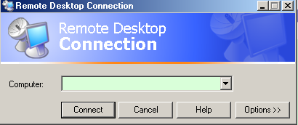

B. Terminal Services Connections MMC snapin

- Ensure Internet connectivity .
- Then go to Start Menu\Programs\Administrative Tools\Terminal Services Connections
- Then configure your connection. (right click as shown in diagram below)

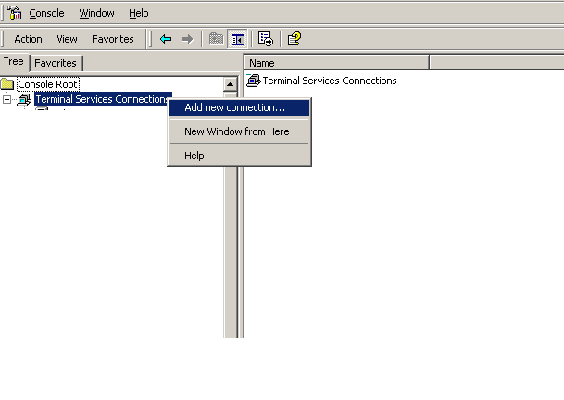

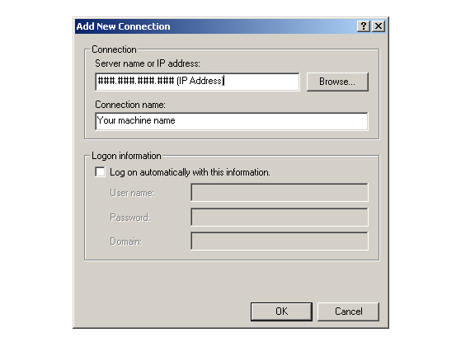

Then key OK, and right click the listed connection, choosing connect.

- After configuring Terminal Services Connections you will be presented with the server desktop. You will then be presented with the Log On to Windows dialog box enabling you to log onto your Windows 2000 Dedicated Server. The MCT intellicentre support staff will issue you the following credentials to log into your Windows 2000 Dedicated hosting Server.

Item | Example
Organisational Unit (OU) | Acme
Username | admin_acme
Password | admin_acme

To authenticate your Server login, enter your issued credentials with the appropriate syntax in the following fields:

Field | Syntax
User name: | {Username}@{Organisational Unit}
Password: | {Password}

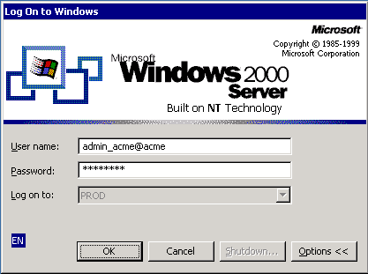

C. Remote Desktop Connection via Web page.

Type URL of http://xxx.xxx.xxx.xxx/rdp51, where the xxx is the IP address of your server.

You will be prompted to enter the username and password. The remote desktop connection app will be displayed.

SUMMARY
This step-by-step guide describes how to share folders on a computer that is running Windows Server 2003 and is part of a domain.
For example, assume that you are the administrator of a Windows Server 2003-based domain. You get a call from the manager of your Accounting department. The Accounting department is working on a major project and wants to have a central location to save their working files. The Sales department has to be able to read these files, but should not be able to edit them or add any new files. You have to create a shared folder on the Windows Server 2003-based file server to allow the Accounting and Sales departments to access the data.

How to Share a Folder
Before you share a folder, you must configure the file and folder permissions to prevent users with restricted access from connecting to the folder over the network.

How to Share a Folder
- Log on to the computer as Administrator or as a member of the Administrators group.
- Click Start, point to All Programs, point to Accessories, and then click Windows Explorer.
- Expand My Computer, and then click the drive or folder in which you want to create a new folder.
- On the File menu, point to New, and then click Folder.
- Type a name for the new folder, and then press ENTER.
- Right-click the folder, and then click Sharing and Security.
- Click Share this folder.
Windows automatically uses name as the folder as the share name (if there is not already another share with that name on the computer). You can change the share name if you want to use a different name.

How to Configure Share Permissions
To configure share permissions:
- On the Sharing tab, click Permissions.
- Click Add.
- In the Select Users or Groups dialog box, double-click the appropriate user accounts or groups (for example, the Accountants and Sales groups) that you want.
- When you finish selecting the users and groups to which you want to grant permissions, click OK. The groups and users that you added, and the Everyone group, are displayed in the Group or user names list.
- In the Group or user names list, click each user or group, and then grant the permissions that you want to the user or group.
For example, to grant Change permission to the Accounting group, click Accounting in the Group or user names list, and then for the Change permission, click to select the Allow check box. To grant Read permission to the Sales group, click Sales in the Group or user names list, and then for the Read permission, click to select the Allow check box.
- After you set the appropriate permissions for the user or groups that you want, click the Everyone group, and then click Remove.
- Click OK.

Troubleshooting

Users Cannot Access Files and Folders That They Should Be Able to When Logged On Locally
Share access permissions are combined from any permissions that are granted directly to the user and those that are granted to any groups of which the user is a member. For example, assume that the user named Frank is a member of both the Accounting group and the Managers group. On one shared folder, Frank has Read permission, and the Accounting group has Change permission. Because Frank is also a member of the Accounting group, his effective permissions are Read and Change.
The exception to this rule is if there is an explicit Deny permission on the folder or file. This occurs because Deny permissions are enumerated first when Windows determines whether or not a particular user can perform a particular task. For example, if Frank is a member of a group that has Deny selected for the Read permission, he cannot read the file or folder, even if other permissions allow him to do so. Therefore, you should avoid using explicit Deny permissions (that is, do not click to select a check box in the Deny column) unless there is no other way to get the specific level of permissions that you need.
Share permissions and the file and folder permissions that can be applied to resources on a drive that uses the NTFS file system are both applied if a user connects to a shared resource over the network. If the share permissions appear as if they should allow for a particular level of access, but the user experiences problems actually achieving that level of access, check the file and folder permissions to make sure that they do not prevent access.

Configuring Storage Devices via Computer Management Snap-In

The System partition has a default total capacity and is formatted as NTFS. You have the preference on how to configure the rest of your hard disk through Windows 2000 Disk Management.

Windows 2000 Disk Management can be found under the Storage branch via the Computer Management Snap-In. The Computer Management Snap-In can be accessed from:

Start | Programs | Administrative Tools | Computer Management

Navigate to the Disk Management Branch under Storage. Right-click on the unallocated partition and select Create Partition from the context menu.

Follow the Create Partition Wizard by selecting create Primary Partition, and then by specifying the size of the partition.

Note: You may specify a smaller disk space size then the maximum disk space and make additional disk partitions if need desired.

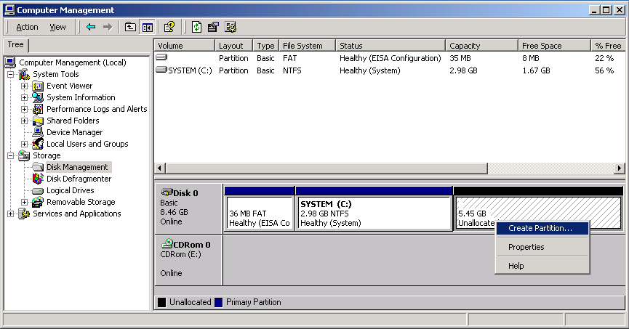

It is highly recommended you format the existing partition(s) as NTFS to take full advantage of the Windows 2000 features and enhanced Security features.

Viewing Server Log Files

In Windows 2000, you have the ability to view logs about applications, security, and system events through the Event Viewer Snap-In. You can use Event Viewer to view and manage the event logs, gather information about hardware and software problems, and monitor Windows 2000 security events.

To open Event Viewer, click Start | Programs | Administrative Tools | Event Viewer. For information about using Event Viewer, click the Action menu in Event Viewer, and then click Help.

Other useful Internet links

To find out additional information on your Dedicated Hosting Server please visit Compaq’s Web Site:

http://www.compaq.com

For more information on Windows 2000 Sever Operating System please visit Microsoft’s Web Site:

http://www.microsoft.com/Windows2000/

8. Help Desk

intellicentre assistance is available 24 hours x 7 days.

If you encounter any problems connecting to your Windows 2000 Dedicated Server, or require additional assistance, please contact the IntelliCentre Help Desk on:

Phone 1800-789-999 Option 2 and then Option 1.

E-mail intellicentrehelpdesk@macquarie.net.au

8.1 Escalation Points

Reporting of Fault Help Desk – On Duty Technician (24x7)
Tel: 1800 789 999
+61 2 8264 3805
Fax: +61 2 8204 5189

1st Escalation Help Desk (as above)

2nd Escalation Mirek Beltowski (Technical Account Manager)
Tel: +61 2 8204 5113
Fax: +61 2 8204 5189
Mobile: +61 0402 893 346
Email: mbeltowski@macquarie.net.au

3rd Escalation Steve Robinson (General Manager)
Tel: +61 2 8204 5115
Fax: +61 2 8204 5188
Mobile: +61 0401 715 269
Email: srobinson@macquarie.net.au

9. Responsibilities

Macquarie Corporate owns, configures, maintains, and administers the platform (base Operating System only).

Customer owns, maintains, and administers the content and applications.

Following the initial installation and configuration, MCT turns over root/administrator access to the customer. Thereafter, the customer is responsible for administration and support of the server and all application software, and for designating qualified personnel to manage the root/administrator access.

Authorised Contacts

Please fill in, sign and fax back to 02 8204 5189

Name | Phone/Mobile | Special Instructions

Name: Signiture: Date:

Company: Telephone:

